The Donum Estate Announces SF Art Week and FOG Design+Art Partnership

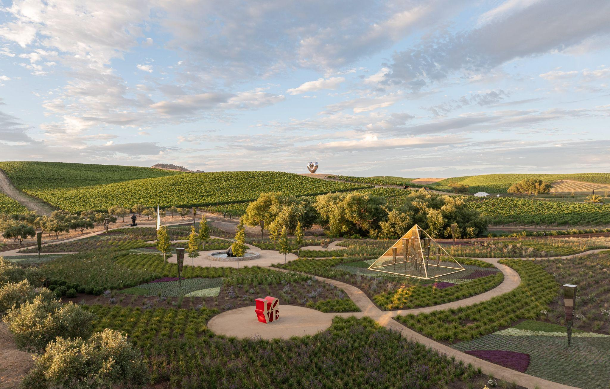
Sensory Garden at The Donum Estate. Photo by Adam Potts.

(Sonoma, CA – December 17, 2025) –The Donum Estate is pleased to announce a dynamic partnership with FOG Design+Art and SF Art Week in 2026. Highlights include a public access day at Donum during SF Art Week; a series of talks developed in partnership with FOG Design+Art, and wine events at FOG. The partnerships with FOG and SF Art Week showcase Donum’s ongoing commitment to supporting art and culture across the Bay Area.

Discovery Day at The Donum Estate

On Monday, January 19, 2026, as a part of SF Art Week, The Donum Estate will host a Discovery Day offering complimentary access to The Donum Collection, one of the world’s largest publicly accessible private sculpture collections. Guests are invited to explore the 200-acre Carneros Estate at their leisure, on foot, between 11:00 AM and 3:00 PM, experiencing monumental works by artists including Yayoi Kusama, Louise Bourgeois, Ai Weiwei, Ugo Rondinone, Anselm Kiefer, Doug Aitken, and Sanford Biggers, set among vineyards and the rolling Sonoma landscape.

Complimentary admission is available for up to 200 guests, with each reservation accommodating up to four tickets. Chef-prepared, grab-and-go lunches featuring estate-grown ingredients will be available for pre-purchase. To support broader accessibility, a complimentary shuttle service will run between San Francisco and The Donum Estate on a first-come, first-served basis; guests are encouraged to indicate interest at checkout. Space is limited, and reservations are required here.

Upon arrival, guests aged 21 and over will receive a welcome pour of Donum wine. Please note that additional wine tasting will not be offered during this event.
FOG Design+Art
As part of its expanded cultural engagement for 2026, The Donum Estate is proud to serve as an Official Partner of FOG Design+Art.
FOG Design+Art commences with the Preview Gala on Wednesday, January 21, 2026. Guests enjoy an evening of culinary creations and beverages, including a tasting of Donum wines.
Donum will deepen its engagement in public dialogue by collaborating with the FOG on talks that offer meaningful access to art, ideas, and curatorial perspectives.
On Saturday, January 24, 2026, at 3:00 PM, Donum will be the presenting sponsor of the talk “Between Light and Legacy: Suzanne Jackson & Alteronce Gumby in Conversation.” The discussion brings together two visionary artists whose practices explore color, materiality, and the expressive possibilities of abstraction across generations.
“We are committed to strengthening the Bay Area’s cultural ecosystem,” said Angelica de Vere Mabray, CEO of The Donum Estate. “Our partnership with FOG Design+Art reflects Donum’s belief in art as a catalyst for connection and cultural dialogue. Together, we can share our collection and values with an even broader community, and we are thrilled to help shape conversations and experiences throughout the 2026 season, beginning with Discovery Day at Donum during SF Art Week.”
Fog Design+Art Fair Director Sydney Blumenkranz says, “The Donum Estate’s dedication to advancing contemporary art and cultivating resonant encounters across art, land, and wine makes them an inspiring partner for FOG. Their support strengthens the fair’s spirit of creativity and community, and we are thrilled for our visitors to experience both their vision and their extraordinary wines.”

Notes to Editors

You will find the press kit here. For further information or to arrange interviews, please contact:

Sutton Communications
Alexandra Ross, donumestate@suttoncomms.com

About The Donum Estate
Founded in 2001, Donum’s terroir-driven wines reflect the energy and complexity of some of the most
celebrated regions in Northern California, including the Russian River Valley, Carneros, Anderson Valley, and the Sonoma Coast. Donum was one of the first wineries in Sonoma County to achieve Regenerative
Organic Certified® status for all of its estate vineyards, and is certified by the California Certified Organic
Farmers (CCOF) association. Donum farms for low yields using regenerative organic farming practices,
cultivating a thriving environment in which the vines can flourish. Located in the acclaimed wine region
Carneros, nestled between Napa and Sonoma Counties, the Donum Estate includes a state-of-the-art
winemaking facility, contemporary hospitality experience, an organic farm, and one of the largest
accessible private sculpture collections in the world. At the intersection of fine wine, sustainable farming
, and world-class art, Donum connects a global community and creates holistic sensory wine experiences
that have made it an international destination.

The Donum Collection®
Founded in 2011, The Donum Collection is one of the largest accessible private sculpture collections in
the world. Over 60 monumental works, including open-air sculptures, are placed on The Donum Estate, a
leader in single-vineyard, single-appellation Pinot Noir and Chardonnay from Sonoma in Northern
California. Dotted throughout, each piece plays with scale, nature, and imagination. This evolving
collection brings together a global community of artists, including works from leading practitioners from
18 nations, across six continents, including Ai Weiwei, Ghada Amer, Doug Aitken, Lynda Benglis, Louise
Bourgeois, Keith Haring, and Subodh Gupta. Donum brings to life a delicate balance among wine, lan,d and art that has made it an international destination. Learn more at https://www.thedonumestate.com/art

About SF Art Week
SF Art Week is an annual event that celebrates the rich arts landscape of the San Francisco Bay Area.

The third edition of SF Art Week will take place January 17-25, 2026. SF Art Week will provide a participant list, program, map, and neighborhood guide with insider tips.

SF Art Week provides special opportunities to connect with diverse participants including art museums, galleries, non-profit organizations and creative spaces in new and meaningful ways.

About FOG Design+Art
Celebrating today’s leading contributors to the worlds of design and visual arts, the fair brings together leading international art galleries; prominent 20th-century and contemporary design dealers; and a weekend of exciting programs.

FOG has become a focal point for the design and arts communities on the West Coast and further afield. The fair is synonymous with a uniquely pioneering spirit due to its bold hybrid approach and intimate presentation of art and design, dynamic programming on-site and its community-led mission to champion art and design in its historic Fort Mason setting. Building on FOG’s longstanding commitment to cultural institutions, the fair’s Preview Gala is honored to continue its crucial support of SFMOMA’s exhibitions and education programs. FOG represents a key moment in which the local and global community congregate to engage in critical dialogue, artistic exchanges, and a shared passion for creative pursuits.

The Donum Estate
24500 Ramal Road
Sonoma, CA 95476

thedonumestate.com

